Contents

Introduction 1

Pre-requisites 1

Setting up your environment 1

Creating a new Windows Azure Sql Database 1

Look at the database in Visual Studio 2

# Introduction

The purpose of this demo is to show the user how to build a Sql Database and use the Windows Azure Powershell CmdLets showing how to use publishsettings files.

# Pre-requisites

Visual Studio 2012 – any edition

Windows Azure Powershell Cmdlets

# Setting up your environment

Import the publishsettings file we downloaded in the earlier visual studio demo.

* Import-AzurePublishSettingsFile -PublishSettingsFile C:\Projects\azurecoder-msr.publishsettings

Set the subscription to a subscription if there were more than one in the .publishsettings.

* Set-AzureSubscription –DefaultSubscription MODISAzure

# Creating a new Windows Azure Sql Database

Enter the following to create a database server.

* New-AzureSqlDatabaseServer -Location "North Europe" -AdministratorLogin "azurecoder" –AdministratorLoginPassword "myP@ssword"

Capture the output of the database name and note it down as we’ll be using it in subsequent commands.

Encapsulate the above credentials using powershell types.

* $cred = Get-Credential

Enter the credentials from above.

* $ctx = New-AzureSqlDatabaseServerContext -Server "dqdudac8dp" -credential $cred

You should see that a message is returned explaining that there is no firewall rule for accessing the server. It should also expose your public IP address. We’ll need this for the next command.

Add the IP address to the firewall. Replace the IP, servername with your own from the above steps.

* New-AzureSqlDatabaseServerFirewallRule -ServerName dqdudac8dp -RuleName msr -StartIpAddress 78.86.150.193 -EndIpAddress 78.86.150.193

We’ll run the context command again now.

* $ctx = New-AzureSqlDatabaseServerContext -Server "dqdudac8dp" -credential $cred

Now that we have the context we can run the command to create the actual database we’re creating a single 1GB database web edition.

* New-AzureSqlDatabase -DatabaseName msr -Edition "Web" -MaxSizeGB 1 -Context $ctx

The database should now be created.

# Look at the database in Visual Studio

We should be able to view the database in VS.NET using the Windows Azure snap-in.

Open Visual Studio and on the left hand navigation pane open up server explorer.

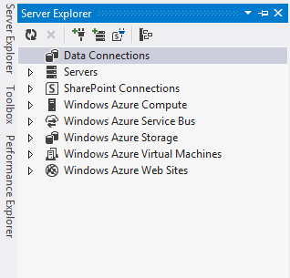

Right-click on **data connections** and choose **add connection …**

The following dialogue should appear.

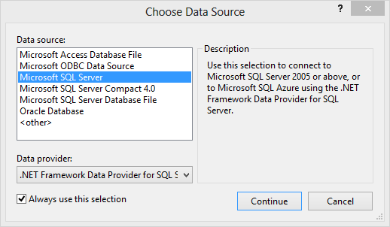

Use the connection details you noted before to connect to the Windows Azure Sql Database.

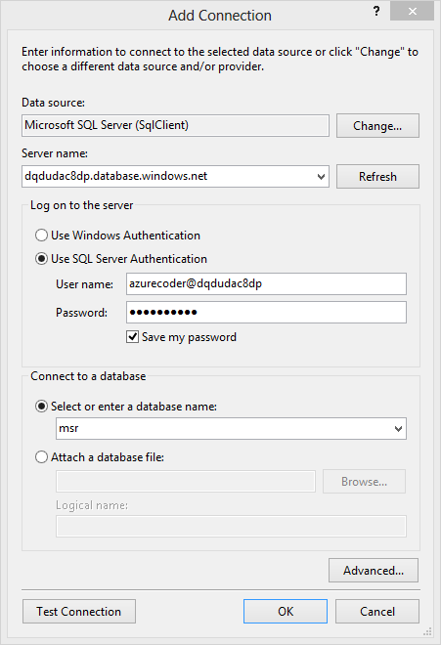

Note:

Server name is in the form of **<server name>.database.windows.net** since this is a publicly accessible endpoint on port 1433.

The username is in the form of **username@servername**

The server explorer should now show the new database.

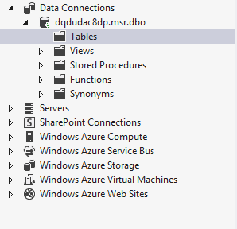

Right-click on table and select **Add New Table.** This will load the visual studio table designer which will generate SQL for you and execute it.

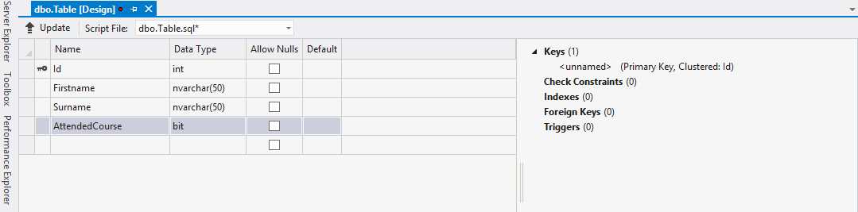

We’ll change the name of the table to **CourseAttendees**.

When the preview window is displayed click on **update database**.

Press **refresh** in the server explorer view. This will display the new table.

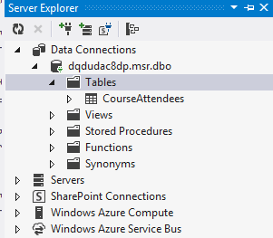

Right click on the new table and select **new query**. Enter the following:

Insert into CourseAttendees(Id, Firstname, Surname, AttendedCourse) Values(1, 'Richard', 'Conway', 1)

Insert into CourseAttendees(Id, Firstname, Surname, AttendedCourse) Values(2, 'Andy', 'Cross', 0)

Insert into CourseAttendees(Id, Firstname, Surname, AttendedCourse) Values(3, 'Wenming', 'Ye', 1)

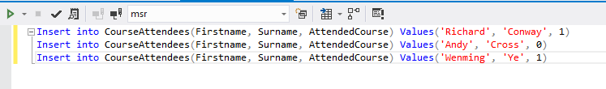

In the query window press the triangle at the top which will execute the query against the database. There is a clustered index on each table in Sql Azure. In this case it is the Id column.

Delete the SQL insert query in the query pane and enter the following.

Select Count(*) from [dbo].CourseAttendees Where AttendedCourse = 1

This will give us the number of people that attended the course so should return 2.